Join optimization
- Select * from t1, t2 where t1.col1 = t2.col1;

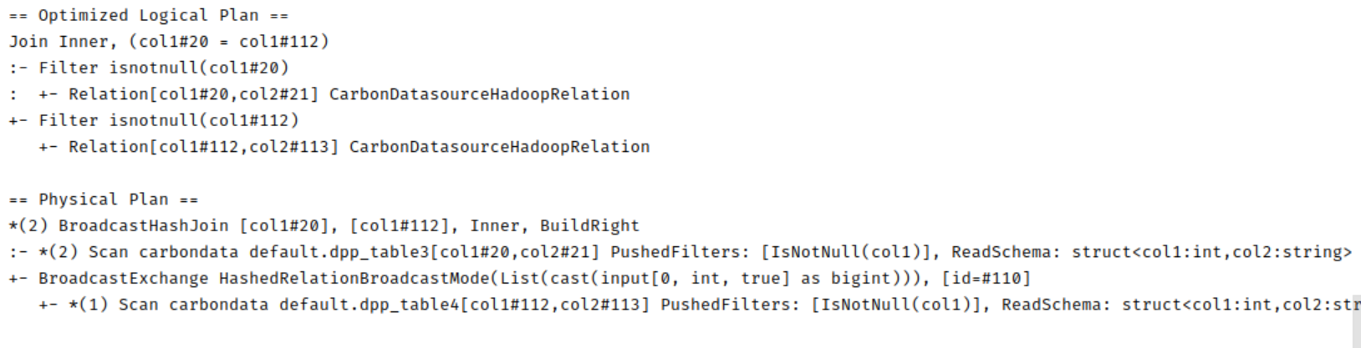

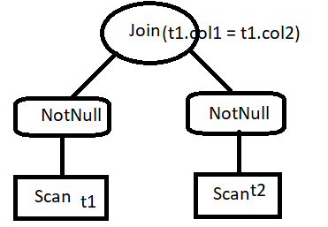

- select * from dpp_table3 t1,dpp_table4 t2 where t2.col1 = 1
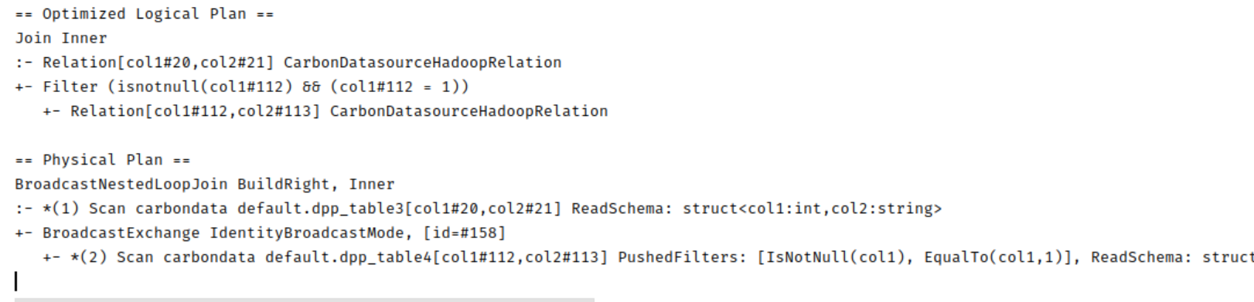
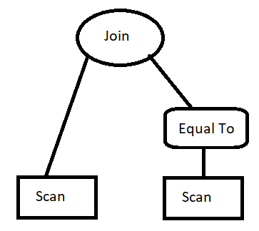

Problem:
- If the t1 is fact table with more data, then it scans whole t1 and then join based on condition
- Filter applies only on right table

Solutions:
- Based on join column, apply min max to left table and filter out the data, better pruning
- Push the filter to left side also for pruning and less scan.

